**COVID COMPANION APP**

Class: BE CMPN-A

Group Name: A9

Group Members: Rishika Ahuja, Ann Zachariah, Aishwarya John, Anashwara Kurien

Guide: Mrs. Jayashri Mittal

**Rationale and Gap Analysis:**

The data cleaning procedure should involve excluding irrelevant cases, correcting some errors in value-coding, and renaming improperly named variables[2]. Sampling studies were not possible during the outbreak. Also this study adopted the way of network questionnaires. These may bring some information bias. It is possible the surveys did not reach underdeveloped areas due to limited technology availability and omitted people who are not comfortable using technology and the Internet[1]. It is unclear to which extent people with psychiatric disorders and medical conditions participated in the current study. Indeed, this may have distorting effects on perceived threat and health[6].

**Introduction:**

The COVID-19 outbreak, which first emerged in China, has been declared as a pandemic by the World Health Organization (WHO). As the coronavirus pandemic rapidly sweeps across the world, it is inducing a considerable degree of fear, worry and concern in the population at large. COVID-19 is putting our mental health at risk since it has been proven stressful for plenty of people[1].A person's mental health affects how they handle stress, relate to one another and make decisions.It also influences the way individuals look at themselves, their lives and others in their lives.Studies show that at least 1 in 5 children and adolescents have a mental health disorder at any given time. Yet, fewer than one in five of these children receive the mental health services they need. Among young people, at least 1 in every 10 has a serious emotional disturbance at any given time. We’re social beings, and we are not meant to live in isolation. Community is critical for us to thrive, especially for someone with mental illness who is already experiencing the common symptoms of loneliness and isolation.Thus there has been an exponential increase in the number of people suffering from mental disorders with the COVID-19 pandemic wreaking havoc all over the globe.

Therefore, our project aims to judge the effect of COVID-19 on the mental health of the users and then suggest to them some basic ways to help them cope with it.

**Objectives:**

The objectives of our project:

* To create a companion system for an individual which helps to analyze the mental health of the being during Covid-19 pandemic.
* To provide precise suggestions to the individual based on their mental condition.
* In cases, the user is found to have critical levels of anxiety and depression requiring professional help, the user will be given exclusive reference to a professional Psychiatric.

**Motivation:**

With the sudden outbreak of COVID-19 which caused complete closure of schools, colleges, work and social life in general and the infectious power of the virus, it is inevitable to see a drastic rise in anxiety, depression and other stress reactions.With the new limitations on daily life and social activities for an unknown period of time, the population will inevitably suffer from stress and anxiety and eventually may lose confidence in life, ultimately taking a toll on the mental health of society. Thus to help every individual through these socially distanced times we decided to take up the project to make a Covid Companion app. An App that will help individuals assess themselves as per their habit inputs if they are likely to have any sort of mental health problems and thus suggest a solution to help cope through the problems in ways that may bring significant changes to one’s daily lives.

**Hypothesis:**

The onset of the pandemic has caused a sudden elevation in mental health disorders all over the world. The mental health disorders in addition to being caused by the sudden change, are linked to the demographics of the people, their personality and their own individual circumstances.

**Research Design and Methods / Research Methodology***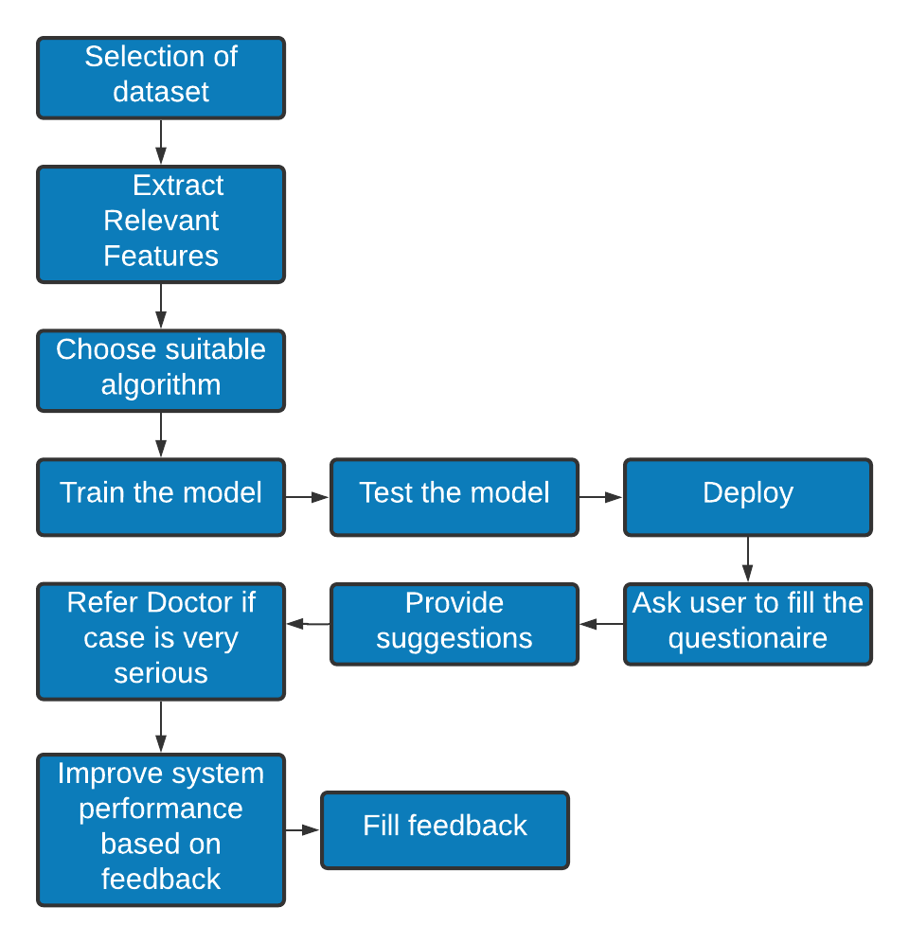*

The above flowchart depicts the architecture diagram for our system.

The first step in this is to select a suitable dataset from the many available options online. Upon selecting a suitable dataset, the suitable features from it will be extracted and an appropriate algorithm for the training of the model will be selected. Once the algorithm is selected the model will be trained, tested and deployed.

The trained model is then deployed in our system where it will take as input from the users via a questionnaire and analyse the mental health of the user on the basis of which suggestions will be provided. In a scenario where the user is found to be having critical mental health the user will be referred to a licensed psychiatrist for proper care. The users will have the capabilities to provide feedback based on the performance of the system which can be utilized later for making the system better and improving its performance.

**Preliminary Work / Survey**

1. Data Cleaning and Preprocessing:

* Null Values were padded to zero
* For Feature Selection PCA (Principal Component Analysis) was used:

The Dataset used for this project has 125306 rows. Large datasets such as this one are often difficult to interpret. Between Principal component analysis (PCA) and Independent Component Analysis(ICA) we chose PCA as ICA gives rise to underfitting in the model. PCA includes steps such as standardization, covariance matrix computation, eigen value and eigen vector computation, feature vector selection and transformation matrix.

1. For Model Training Long Short Term Memory (LSTM)

LSTM networks are an extension of recurrent neural networks (RNNs) mainly introduced to handle situations where RNNs fail. An LSTM network consists of four gates namely the input gate, input modulation gate, forget gate and the output gate. Using the LSTM algorithm we further train and test our model.

**Expected Outcome/s:**

While testing the model using classification report and confusion matrix, the number of false positives and false negatives should be minimum. The precision score and recall score should be as optimum as possible. We aim to obtain a perfect F1 score of 1.0. The F1 score is a weighted harmonic mean of precision and recall.

The model should be able to correctly predict the anxiety level of the user and also find out the stress level of the patient based on the demographics. The suggestions provided should be accurate and shouldn’t trigger the user in any manner. For extreme anxiety levels, the model should automatically transfer the user’s details to a certified psychiatrist.

**Benefits to the Society:**

The global Coronavirus Disease 2019 (COVID-19) pandemic affected millions of people and forced the mobilization of governments worldwide.Such sudden changes have a direct impact on a person's mental health.This project aims to increase the mental wellbeing of the users and reduce their depressive symptoms. We aim to increase mental health awareness among the general public and help them cope with the stress and hardships caused by the sudden onset of this pandemic. Mental health awareness increases the chances for early intervention, which can result in a fast recovery. Awareness reduces negative adjectives that have been set to describe our people with a mental illness. By raising awareness, mental health can now be seen as an illness. These illnesses can be managed by treatment. [Mental disorders](https://medlineplus.gov/mentaldisorders.html) are serious conditions which can affect your thinking, mood, and behavior. They may be occasional or long-lasting. They can affect your ability to relate to others and function each day. But there are treatments. People with mental disorders can get better, and many of them recover completely. Our project hopes to build an app that proves to be a worthy companion to the mental health of those suffering in these hard times by helping them access the state of their mental well being and providing simple measures to help them cope with it and begin their journey on the path of recovery.

**Cost Benefit Analysis:**

| **Requirements** | **Specifications** | **Cost** |
| --- | --- | --- |
| **Hardware:** |  | |
| CPU | Intel Core i5 9300H |  |
| Motherboard | Covini_CFS HM370 |  |
| HardDisk Space | 1 TB |  |
| Display | 1080 FHD 15.6inch |  |
| Memory | 2666Hz 8gb DDR4 ram |  |
| Other Devices | Laptop / Android Smartphone |  |
| **Software:** |  | |
| Application | Streamlit, Colab Notebook |  |
| Language | Python |  |
| Operating System | Windows 10 |  |
| **Total Cost** | 72709.05 | |

**Future Scope:**

THE GLOBAL COVID-19 pandemic, its economic fallout, and the companion global confrontation with issues of social justice have together caused enormous strain on the mental and behavioral health of people across the globe. Everywhere, there have been spikes in anxiety, depression, and other behavioral health issues as people navigate the complexity of the current moment. These spikes are extensions of a long-simmering crisis in global mental health.

And the pandemic is increasing demand for mental health services. Bereavement, isolation, loss of income and fear are triggering mental health conditions or exacerbating existing ones. Many people may be facing increased levels of alcohol and drug use, insomnia, and anxiety. Meanwhile, COVID-19 itself can lead to neurological and mental complications, such as delirium, agitation, and stroke.

COVID-19 has interrupted essential mental health services around the world just when they’re needed most. Creating a Covid companion system could not only address a pressing social challenge but also improve health care outcomes, reduce health care costs, mental conditions of the being and create a healthier, happier, and more productive workforce.

In the future we could develop this application and widen the scope of this project for various other diseases like cancer, cardiovascular problems, etc. We could add into this a module which provides a platform for online consultations with psychiatrists and other physicians.

**SWOC Analysis / Limitations**

The challenges identified are as follows:

* The mental health of a user should be quantified objectively and accurately for proper care to be provided.
* In cases where the mental health is found to be critical care should be taken that the user is referred to a psychiatrist on an urgent basis.
* The suggestions need to be carefully curated to help the users.
* If the users find the suggestions to be triggering in any manner, the suggestions need to be changed immediately.

**References:**

1. Yenan Wang, Yu Di, Junjie Ye & Wenbin Wei, “Study on the public psychological states and its related factors during the outbreak of coronavirus disease 2019 (COVID-19) in some regions of China, Psychology, Health & Medicine”, 2020.
2. Yamada, Y., Ćepulić, DB., Coll-Martín, T. *et al.,* “COVIDiSTRESS Global Survey dataset on psychological and behavioural consequences of the COVID-19 outbreak.”  *Sci Data* 8**,** 2021.
3. Sherman A. Lee, “Coronavirus Anxiety Scale: A brief mental health screener for COVID-19 related anxiety, Death Studies”, 2020.
4. Sherman A. Lee, “Measuring coronaphobia: The psychological basis of the Coronavirus Anxiety Scale”, Dusunen Adam: The Journal of Psychiatry and Neurological Sciences”,2020.
5. Kubb C, Foran HM, “Measuring COVID-19 Related Anxiety in Parents: Psychometric Comparison of Four Different Inventories”, *JMIR Mental Health*, 2020.
6. Eder SJ, Steyrl D, Stefanczyk MM, Pieniak M, Martínez Molina J, Pešout O, et al., “Predicting fear and perceived health during the COVID-19 pandemic using machine learning: A cross-national longitudinal stud”,2021.
7. Ćosić, Krešimir et al. “Artificial intelligence in prediction of mental health disorders induced by the COVID-19 pandemic among health care workers.” *Croatian medical journal vol. 61,3*, 2020.